Emily Wantland

Prof. Karimi

CIS 310-01

27 April 2020

**49.**

/*CIS 310-01 Emily Wantland*/

UPDATE

MOVIE

SET

Movie_Year = 2014

WHERE

Movie_Num = 1245;

SELECT

*

FROM

MOVIE;

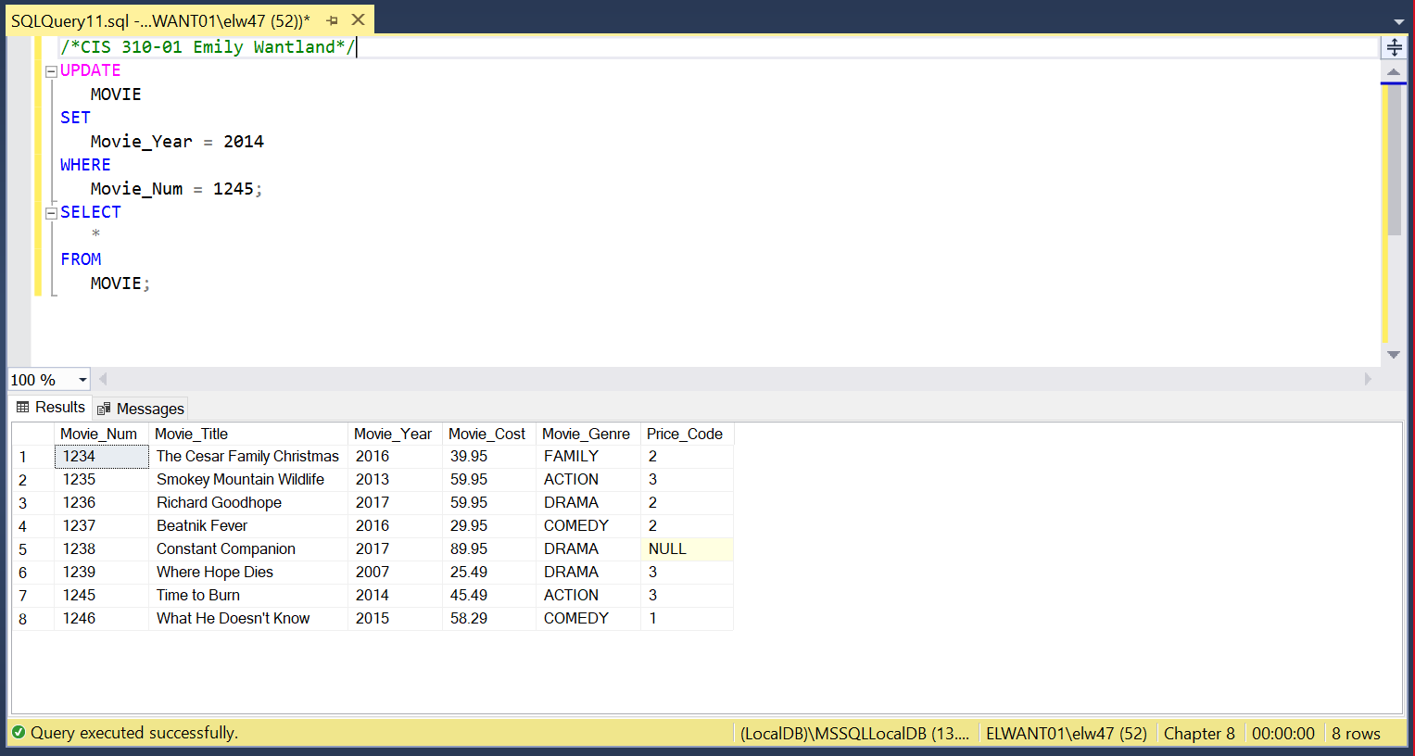

**50.**

/*CIS 310-01 Emily Wantland*/

UPDATE

MOVIE

SET

Price_Code = 3

WHERE

Movie_Genre = 'ACTION';

SELECT

*

FROM

MOVIE;

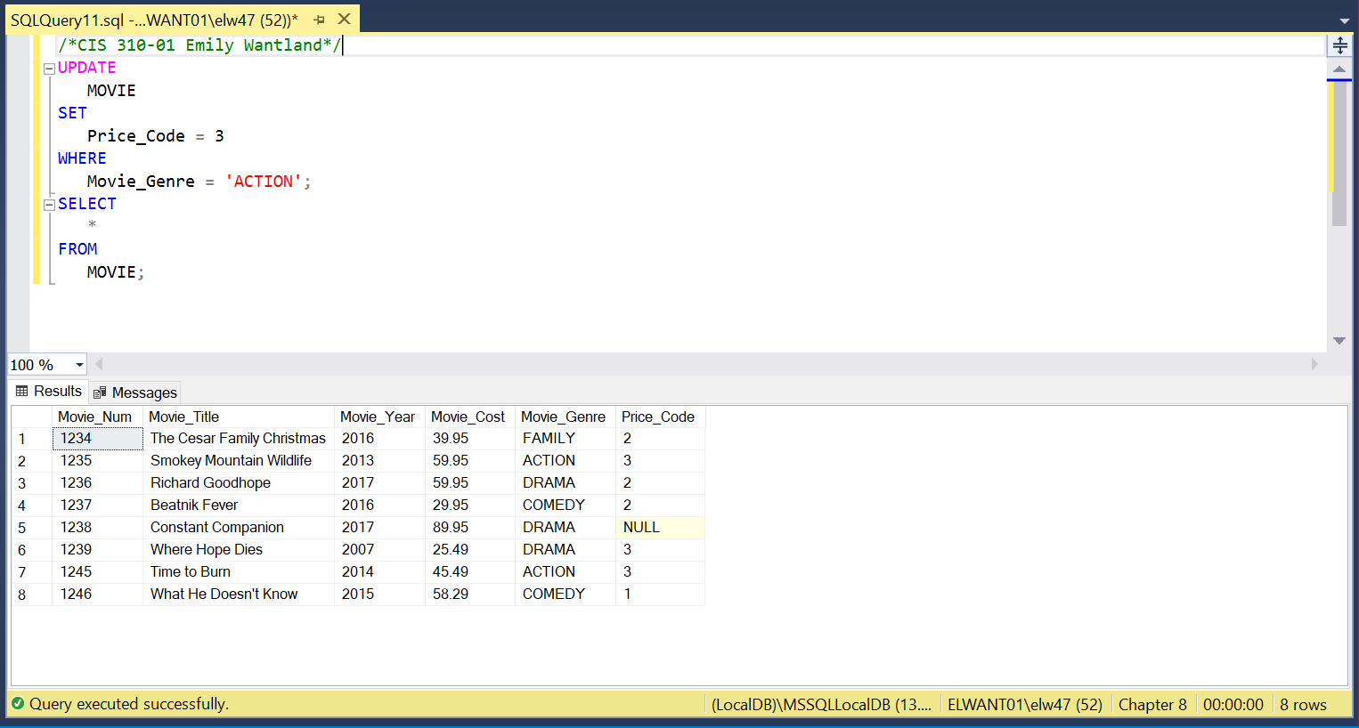

**51.**

/*CIS 310-01 Emily Wantland*/

UPDATE

PRICE

SET

Price_RentFee = Price_RentFee + 0.50;

SELECT

*

FROM

PRICE;

